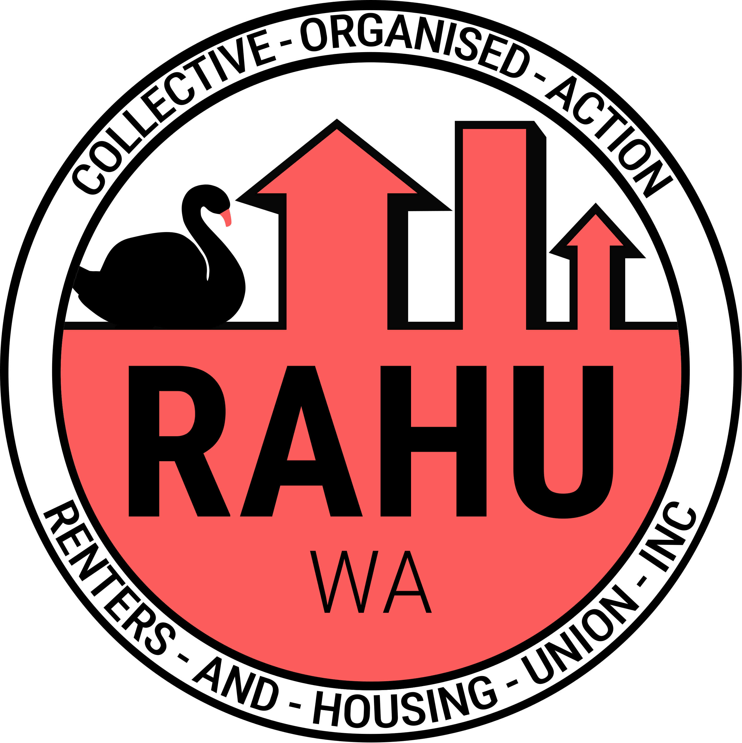
Renters And Housing Union (RAHU) Western Australia Branch Statement

In response to WA Government’s announcement:
“Landmark partnership to deliver nearly 1,800 new social and affordable homes for Western Australians”

Statement:
The increase housing that the government has announced remains insufficient.

According to the Property Council of WA, over 92,000 homes need to be constructed by 2027 merely to sustain the current supply levels. Even at the existing rates, we are already witnessing significant challenges related to housing affordability and rising rents.

An additional 1,800 affordable and social housing units represents a minimal contribution in the context of the broader rental crisis we are experiencing.

Further, this new housing remains in developer and private hands. These landlords and developers will be getting public funds but keep profits for own private gains. Meanwhile us Western Australian renters are left paying too much into a system built around their exploitation, and consistently treats us as disposable.

If the state government is genuinely committed to affordability and improving conditions of renters, it has the opportunity to adopt effective policies that have been implemented in other (so called) Australian states.

Such measures could include, but are not limited to, the introduction of vacancy taxes, a cessation of the sale of public housing and investment in this sector, the application of stricter rent controls in (so called) Western Australia, and the prohibition of no-fault evictions.

RAHU WA remains dedicated to advocating for renters throughout Western Australia, both through dialogue with the government and direct action.

For too long renter’s have been getting the short end of the stick in West Australia, and we are standing up and fighting back.

Quote attributable to RAHU national delegate:
“The investments are just giving handouts to contractors without any regulation on prices after the houses are built.“

For further media enquires:
0437227463
media@rahu.org.au
wa@rahu.org.au

https://www.wa.gov.au/government/media-statements/Cook%20Labor%20Government/Joint-media-statement---Landmark-partnership-to-deliver-nearly-1,800-new-social-and-affordable-homes-for-Western-Australians-20241201
https://www.watoday.com.au/national/western-australia/wa-s-housing-shortfall-is-worsening-could-lego-style-homes-speed-things-up-20240321-p5fe8j.html

